# An Observation and Analysis of the Migros Self-checkout

By Luca Hollenstein, 15-159-460, luca.hollenstein@uzh.ch

Oliver Hliddal, 18-737-528, oliver.hliddal@uzh.ch

Inhalt

An Observation and Analysis of the Migros Self-checkout 1

1. Description of system, environment & approach 2

2. Reporting of observations 3

2.1 Person 1 (New system) 3

2.2 Person 2 (New system) 3

2.3 Person 3 (New system) 3

2.4 Person 4 (Old system) 3

2.5 Person 5 (Old system) 3

2.6 Person 6 (New system) 4

2.7 Person 7 (New system) 4

2.8 Person 8 (New system) 4

2.9 Person 9 (New system) 4

2.10 Person 10 (Old system) 4

3. Analysis of system and observations 5

3.1 Approaching the self-checkout 5

3.2 Scanning the products 5

3.3 Finishing the process 7

## 1. Description of system, environment & approach

For the assignment we have chosen to analyze the self-checkout at Migros. The self-checkout is an alternative to the operated cash register. The key advantages are that you no longer must wait in line for an operated cash register and it is especially convenient for small purchases. The usage is available for all customers, whether you have Cumulus-Membership or not. The self-checkout stations are in the exit area.

After you have found all your groceries you are ready to start with the process of the self-checkout. The following steps are required to finish you purchase:

* Select a self-checkout station
* Scan your products
* Confirming that all items were scanned
* Scan Cumulus-Card if available
* Scan Cumulus-voucher/ coupons if available
* Finish your payment

The task was to go to Migros and buy multiple products using the self-checkout to finish up your purchase. In order to see more of the system an additional task was to scan a product once more than the amount that was bought and remove it afterwards from the item list.

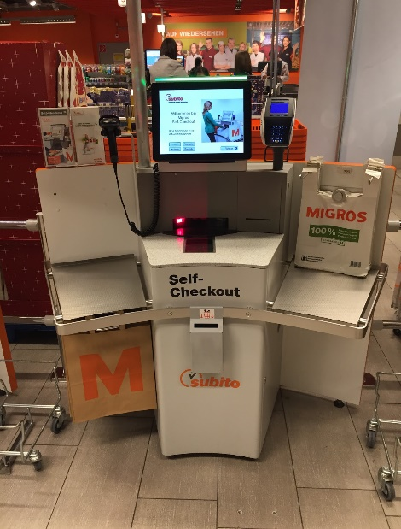We decided to join the grocery store visit of ten testers and observe the usage of the self-checkout system at the end of their purchase. We mainly looked out for features of the system that resulted in the person taking an unusually long amount of time to finish their step. To make it as normal as possible, we firmed to remain in the background like a “fly on the wall” and observe the process by looking over the shoulders of the test-users. To prevent uncomfortable settings, we decided to exclude the payment process from the analysis to protect our testers to use sensitive information during the observation. To get as much information as possible we conducted the observation together, one took notes during the observation, the other one just observed the process carefully to not miss anything. Right after it we debriefed the observation and rounded it off. For further analysis we took some photographs of the system.

Picture 2: The older system. It has two smaller counters on each side.

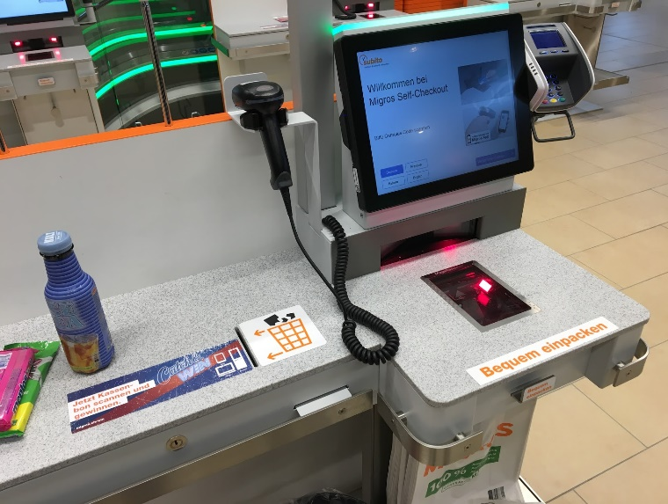Something to note about this system is that there is an older (Picture 2) self-checkout-system which is used mostly in stores that got the system when Migros first launched it. A newer version (Picture 1) is used in newer stores (i.e. the newly renovated store at Kreuzplatz, Zürich). Apart from evaluating the two systems by themselves, we will also draw comparisons between the two and look at potential improvements in the newer version. We have marked with every person, whether they used the old or the new system. Unfortunately, it wasn’t possible to have all people use the same system.

Picture 1: The newer system. It has a big counter to the left side.

## 2. Reporting of observations

### 2.1 Person 1 (New system)

Person 1 went to an available self-checkout terminal next to the exit. They started scanning all the products by the built-in scanner of the self-checkout terminal. The language selection was ignored. After scanning one product twice by mistake they deleted the double scanned product by clicking the Minus-button on the lower left corner. After that they proceeded by clicking the “Weiter”-Button. Cumulus and discount voucher were not used. They confirmed that all products were scanned. After the payment they stored all the products in a backpack on the right side of the terminal. The receipt was removed and put it in a bin right next to receipt-printer.

### 2.2 Person 2 (New system)

Person 2 did not select a language and scanned their first item quickly. They found the barcodes quickly and scanned them. Person 2 did not scan a product twice. They pressed the skip-button in the scan Cumulus-card section. When selecting a payment method, they had to look for the “Kartenterminal”-option to pay with a debit-card. They used contactless payment for their purchase. They had to look for the receipt a bit, as it came out on the other side of the self-checkout screen as the positioning of the credit-card-terminal.

### 2.3 Person 3 (New system)

Person 3 selected German as their language. They started scanning their products. One of their items scanned twice by accident when they tried to put it to the side and moved it over the scanning area for a second time. It took them about 4 seconds to find the Minus-button which is used to remove an object. Their last object was a small bread which did not have a barcode. They opened the menu to add small breads and selected theirs. They then quickly went through the Cumulus-card-menu and paid with their credit card.

### 2.4 Person 4 (Old system)

Person 4 went straight up to the first available self-checkout terminal. They placed a brought bag on the right stacker of the terminal. Next, they started with scanning the products. After scanning one product twice by mistake, they touched the minus-button on the lower left corner of the screen and confirmed it. When all products where scanned and stowed in the bag, to finish the process they touched the “Bezahlen”-Button and confirmed that all items were scanned. Next, they scanned the cumulus as asked and the screen showed that it was successfully detected. No Coupons and ”Cumulus-Bons” where scanned. After selecting the payment method and paying for the groceries they removed the receipt and went on.

### 2.5 Person 5 (Old system)

Person 5 placed their shopping basket on the left stacker side of the self-checkout terminal and started right after with the scanning of the products which were stored in a plastic bag on the right side of the terminal. They noticed to scan the plastic bag too, for that they reached out for the mobile scanner. The doubled scanned product was removed by touching the minus-button and confirmed it. Next, they clicked the “Bezahlen”-button and again confirmed it. They did not use a Cumulus-Code and proceeded by touching the “Weiter ohne Cumulus”-Button on the lower left. Same for “Cumulus-Bons”. After the payment they took the receipt and put in in a little trash-slot in the middle of the terminal.

### 2.6 Person 6 (New system)

Person 6 got to their machine and started scanning their products. When trying to add the small bread they wanted to buy, they had to search for the correct button for almost ten seconds. They didn’t have any problems with any of their other products, scanning their Cumulus-card and paying.

### 2.7 Person 7 (New system)

When person 7 was heading to check-out, all the self-checkout-machines were occupied. When a machine got free, a green light above it went on. They went to the self-checkout-machine and waited for the person before them to finish packing up their things. They then scanned their products using the built-in scanner. When trying to remove an object, it took them multiple seconds to find the correct button. When trying to click it they accidentally pressed the plus-button located directly next to the minus-button, which added another unit of the last-scanned object. They then had to remove the object in question twice to pay the correct amount. Person 7 used scanned a Cumulus-card when they got to that section using the built-in scanner.

### 2.8 Person 8 (New system)

Person 8 had the same issue as Person 7 with all machines being occupied. When the light above a machine turned green, they observed the person at the machine and waited until they had left until they approached the machine. One of the objects they tried to scan had a barcode that was on a scrambled etiquette so they had to manually flatten it, as the machine couldn’t recognize the barcode.

### 2.9 Person 9 (New system)

Person 9 got to their self-checkout-machine quickly and was very swift in scanning all their items. They had no trouble removing the additional item. They did not scan any Cumulus-card and paid.

### 2.10 Person 10 (Old system)

Person 10 placed their shopping basket on the left stacker of the terminal. A heavy item was placed on the floor next to it. They changed the language to German by clicking the “Deutsch”-button and continued with touching “Weiter”. They scanned the product on the floor with the mobile scanner twice and changed it back to the required amount, by clicking the minus-button and confirmed it. The rest of the products were all scanned by built in scanner. For multiple products of the same kind, they scanned one, then pressed “plus” until they reached the desired amount. They finished by clicking “Bezahlen” and confirmed it. The “Cumulus-Code” was successfully scanned and detected. No vouchers where used, so they skipped the next two screens. After the payment was completed, they put the shopping basket on a tower of empty baskets right next to the machine. The receipt was removed, crumpled and then thrown away in a trashcan in the exit area of the grocery store.

## 3. Analysis of system and observations

### 3.1 Approaching the self-checkout

When you walk up to the exit of a Migros Store there are operated cash register, self-scanning checkouts and self-checkouts. The self-scanning checkout uses mobile scanners that the users can pick up at the entrance of the store and use to scan their products while going through the supermarket. When checking out, the scanning-device is connected to the checkout-machine, which is used for all the other steps of checkout. The self-checkouts have the scanners built into them and all products are scanned when the user leaves the store. For this paper, we look at the self-checkout system.

Both types of system have deliberate signifiers in form of a sign, indicating what type of system there is under it. For inexperienced customers the self-scanning and the self-checkout signs might be confusing in the first place. Only the self-checkout terminal allows you to scan your products right at the terminal. This difference in affordance results in the systems looking differently and an experienced user will immediately be able to tell whether a station is self-checkout or self-scanning. Inexperienced users might go to the wrong type of machine which will result in an error of interpretation on the 7-Stage Model.

Another signifier can be other users that are using the self-checkout terminals. This is an unintentional signifier.

Another signifier is a green light that illuminates on every available terminal, to signify that it is ready to use. One problem this light can have is that often people pay before packing their items into their bags, therefor using the space of and around the station without using the virtual system. The light turns green as soon as the payment process has been finished, resulting in the next person possibly already approaching the machine without having the space to use it. Especially in bigger stores with a lot of checkout machines (i.e. Migros HB) and during rush hour with a lot of people walking around, these lights are the best way to see if a machine got available. If the machine goes green without the person that just used it having left the space, it can result in more people blocking area in a space, that’s already rather small or people having to wait additionally. *(e.g. Person 7 as coming too soon and Person 8 as the appropriate behavior)*

On the other hand, the green light works as a feedback for the customer and the staff that the payment process was successful. The light can also turn red, telling staff that there is an issue or that a customer needs assistance.

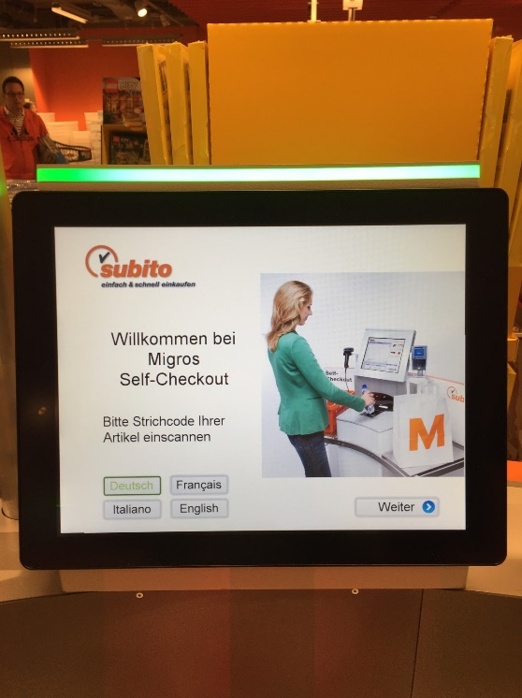

### 3.2 Scanning the products

The start of the system immediately differs between the old and the new system. The old system works as follows:

On the first screen the user is asked to start scanning their products or to select a language (Picture 3). We observed that experienced customers start scanning their products right away, without selecting a language. Less experienced customers note the screen first, check the language selection and continue by pressing the “Weiter”-button or selecting a different language.

Picture 3: The old system asks the user to start scanning their products. The new system asks the user to scan their Cumulus-card first, expecting the user to know how to scan their products.

The new system asks to scan the users Cumulus-code instead of asking the user to scan their products. There’s also a picture showing the user how to scan their physical Cumulus-card and another picture telling the user that they can pay with the Migros-App. Both are signifiers, telling the user what Migros wants them to do. Instead of the “Weiter”-button in the old system, there’s a “Weiter ohne Cumulus”-button, in order to skip this step. In both cases it is possible to immediately start scanning the products, which will automatically take the user to the next page.

We believe that this difference between the old and the new system is because they were deployed into different worlds of self-checkout-machines. The old system was designed more to teach users the newly introduced self-checkout way of paying and the new system was designed for a world where most people already know how to use a checkout-machine. Having a system that most users are already familiar with gives Migros the freedom to give the user information about affordances that they want them to use but are not a necessity (e.g. Migros-App, Cumulus-card). Another advantage of having these affordances at the start is that scanning a Cumulus-card is not a step on its own like in the old system, resulting in the average time of usage of the system being shorter.

The built-in scanner works as a signifier and an affordance, it lights up red to signify that it is ready to use and most of the people have seen a cashier scan their products so it is not hard to understand what has to be done. Incase this is not clear on the first screen of the old system there is a picture of a woman scanning her products to help indicate to the user what to do.

There is not only the build-in scanner, there’s another mobile scanner that can be used to scan products that are too heavy to lift onto the counter.

While scanning your products you get different kinds of feedback. Every time you scan an item you get an immediate auditory feedback, that shows that your scanning is successfully detected. In addition to that the item immediately pops up at your screen and shows detailed information. The number of items, the exact specification of the product and the price. If you get a discount on an item, it signifies it that it shows up a yellowish color and what you save. These feedbacks were useful for the testers to detect the multiple scan they did by mistake.

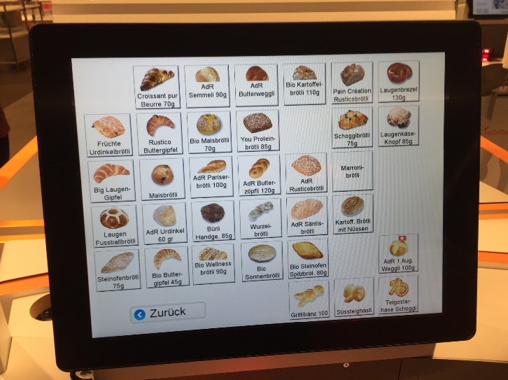

Some items don’t have a barcode, so these items must be added manually. These items are divided into the categories small breads, sweet pastries, salty pastries, fruits, vegetables and others (Picture 5). When clicking on one of these categories, a menu shows up with all the items of said category that can be bought at that store (Picture 4). It seems like the positioning of each item is the same in every store, but items that are not sold in a store don’t show up, resulting in very strange and random gaps in the menu. There also seems 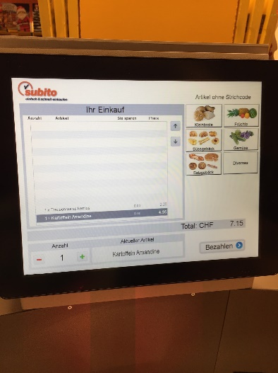to be no logical order of these items. The terrible mapping makes the menu very challenging to use and concludes with the user potentially taking a long time to find their item. *(e.g. Person 6)*

Picture 4: The selection of all small breads.

Once the scanning process has started, a constraint occurs, an interlock. They make sure that the shopping is finished in a particular sequence. But if one forgets something and wants to break off and go back into the store, there is no way to abort the process. It also prevents ending the process prematurely. This could be to avoid people scanning their products, canceling and leaving without paying.

### 3.3 Finishing the process

Picture 5: Overview of all scanned products. On the rights side are the categories for products without barcodes. Below that are the total and the “Bezahlen”-button.

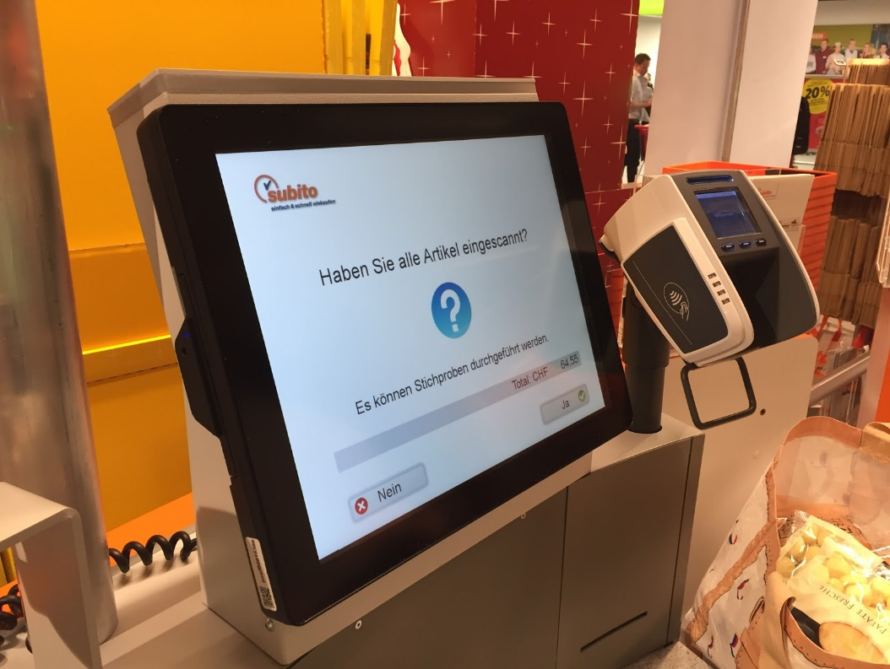When all products are added, the user can press the “Bezahlen”-button (Picture 5). They are then asked to confirm that all products are scanned and warns them about potential randomized controlling (Picture 6). This serves two things: it stops people from prematurely finishing the scanning process (both by accident or intentionally) and it discourages people from potentially stealing, both now and in the future.

Picture 6: Confirmation screen.

The old system now has two additional steps: asking the user about their Cumulus-card and using a gift-card or discount code. Both steps can be skipped with a button that is located at the exact same place and has the same color and size as the “Weiter button”. This helps the user to get through the system quickly, as they don’t need time to move their finger from one place to the other (Reducing the time used as calculated by KLM & Fitts’s Law).

The new system has the Cumulus-card being scanned at the beginning and the discount-code and gift-card as a separate menu that can be accessed from the “select-payment”-page.

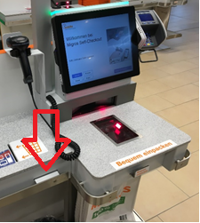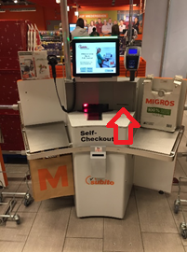

Another thing that kind of stuck out was the positioning of the receipt-printer compared to the payment-terminal in the old vs. the new system. In the old system the receipt gets printed below the terminal (Picture 7), while in the new system the printer is on the other side of the machine and comes out below the height of the counter (Picture 8). This can result in users taking a longer time to get their receipt when first using this system or the receipt being hidden in the users view if there are overlapping items lying around on the counter. While printing the receipt, the system gives you a feedback in form of sound of a printer.

Picture 7: Position of the receipt printer in the old system.

Picture 8: Position of the receipt printer in the new system.